Please give us a two day notice for all orders.
Last day to order will be Thursday 11/20/2025
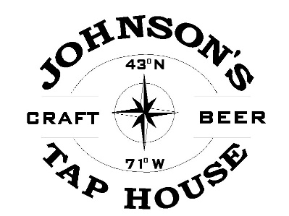
Orders will be ready for pick up by 11am on the chosen day.
Name: ________________________________
Phone Number: ________________________
Date of Pick-up: ________________________
Pick-up Location: _____________________________
WE WILL BE CLOSED THANKSGIVING DAY 10/27/2025

Please call the restaurant if what you would like to order
is not on this list to ensure it can be made.
Please Circle Order
9” Deep Dish Fruit Pies $18.50
Apple
Blueberry
Strawberry Rhubarb
Mixed Berry
9” Cream Pies $18.50
Coconut Cream
Chocolate Cream

Other Pies and Cakes
9” Pecan Pie $20
9” Pumpkin Pie $18.50
Full Mocha Ice Cream Cake $22.50
20 Large Cookie Platter $40
‧ Chocolate Chunk Cookie
‧ Peanut Butter Chunk Cookie
‧ White Chip Macadamia Cookie

Allergy Info: We use nuts in our bakery

